Chapter 11, Problem 16.

For the circuit in Fig. 11.47, find the maximum power that can be delivered to the load Z_{L}.

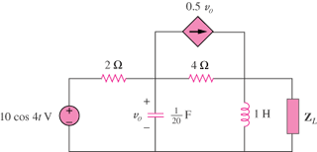

Figure 11.47
For Prob. 11.16.

